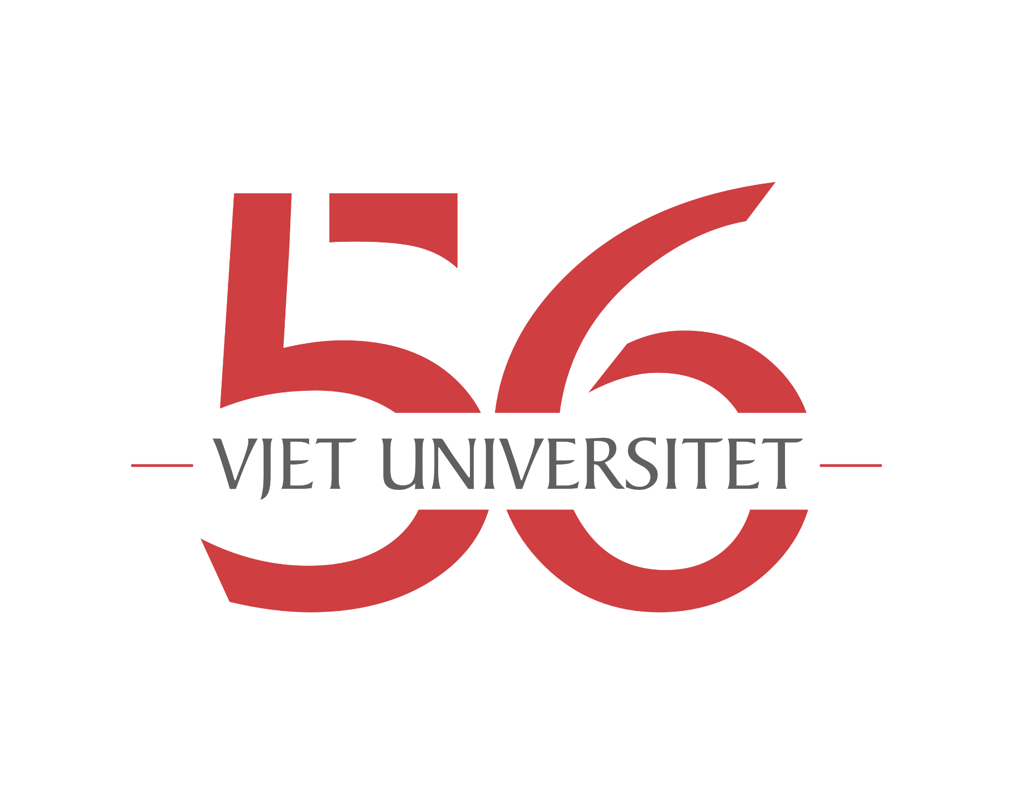
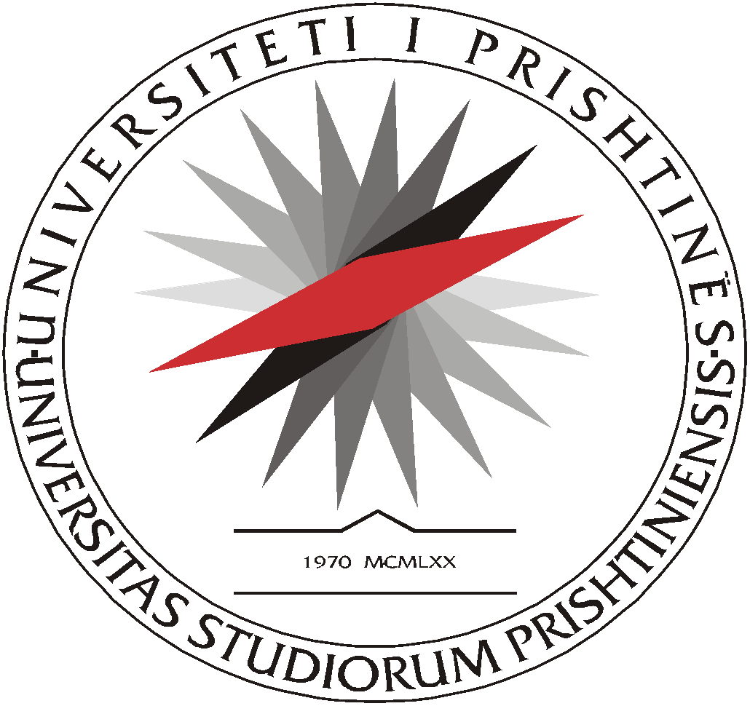

UNIVERSITETI I PRISHTINËS
UNIVERSITY OF PRISHTINA

Speech by Rector Arben Hajrullahu on the 56th Anniversary of the University of Prishtina
Prishtina, 13 February 2026

Honorable Deputy Minister of Education Mr. Arsim Ademi,
Honorable Vice President of the Kosovo Academy of Sciences and Arts Mr. Fejzullah Krasniqi,
Honorable ambassadors, partners, friends and donors of UP,
Honorable members of the Governing Council, deans, professors and students,
Ladies and gentlemen, distinguished guests,

Major and significant anniversaries, such as this 56th anniversary of the University of Prishtina, are solemn occasions marked by respect, pride, and reflection on the past, as well as by aspirations for the future. Since its establishment, nothing at the University of Prishtina has come easily, and nothing has been taken as given. Built and sustained by the strength of its people, this university endured severe periods marked by: persistent discrimination against the majority population, apartheid and expulsion from its premises in the 1990s, and both civil and armed resistance. The University of Prishtina was never broken, never halted; it kept moving forward, like a beacon, alongside the fate and aspirations of the people of this land towards a more developed, brighter and more peaceful future.
Leading an institution like the University of Prishtina is both a great responsibility and a singular, once-in-a-lifetime honour. For the people of Kosovo and beyond, the University of Prishtina has long been seen as more than a university. It has been, and remains, a source of hope for development and a better future. This is why the people of Kosovo opened their homes to the students and professors of the University of Prishtina when they were forcibly expelled from their premises, and why they were prepared to defend the university even at the cost of their lives. The University of Prishtina is therefore part of Kosovo’s memory and history, one of its brightest chapters, while also embodying the pride and future of the people of this land.

Distinguished guests, professors and students,
A great many of those gathered here today, and indeed many beyond this hall, across Kosovo and further afield, completed their higher education at the University of Prishtina. Many have built or continue to build their careers here, whether in teaching or in scientific research, and therefore have personal experiences closely bound to the University.
The history, events, and development of the past five or six decades in Kosovo cannot be understood, cannot even be imagined without the University of Prishtina. The students and professors of the country’s leading university stood at the forefront of the complex processes that led to freedom, liberation, and state-building. Expectations of the University of Prishtina were, and continue to be, very high. Accordingly, work for the common good, for the University and emanating from it, must never cease.

Honourable partners, donors, ambassadors and state leaders,
With its rich heritage and history, its strong presence, and its tangible achievements, the University of Prishtina is firmly focused on the present and looking to the future. We honour the past with respect and pride, while working diligently to shape the present and the future. Recently, for example, we established the Centre for Artificial Intelligence at the University of Prishtina, enabling students to equip themselves to fully harness rapid technological advances in an ever-evolving labour market.
The University of Prishtina also has a comprehensive digital transformation plan, developed by the United Nations Development Programme. While the University is unable to finance its implementation independently, it could be fully realised with the support of the friends and partners of this University and of this country. I therefore wish to make a public appeal: stand with us, support us, so that we may keep pace with the rapid and far-reaching developments of our time.
We have also begun to put into practice the idea of “brain gain and brain circulation”, strengthening ties with professionals and professors from the academic diaspora who work at, or have completed their studies at, 400 of the world’s most renowned universities. In recent months, Professor Gëzim Visoka of Dublin City University and a research fellow at the University of Oxford; Professor Dukagjin Blakaj, physician and professor at The Ohio State University; Driton Vllasaliu, pharmacist and professor at King’s College London; and Besnik Pula, professor at Virginia Tech in the United States, have all been affiliated with the University of Prishtina. In our common home, the University of Pristina, the door is open to all professors and experts interested in joining us in our mission.
No university can survive or provide quality knowledge in isolation. For this reason, internationalisation is given special attention at the University of Prishtina. In 2025 alone, 232 students and 104 members of academic and administrative staff experienced learning, teaching and training at higher education institutions abroad, while 125 students from across Europe and the world, together with 101 visiting professors and lecturers, came to Prishtina to contribute to the strengthening of knowledge.
The past year was also marked by several anniversaries, combining pride with nostalgia and serving as testimony to the work accomplished. In addition to celebrating the 55th anniversary of the University of Prishtina, we marked the 65th anniversary of the Faculty of Philosophy, the 58th anniversary of the Faculty of Mechanical Engineering, the 50th anniversary of the Department of Dentistry within the Faculty of Medicine, and half a century of the Department of Music at the Faculty of Arts.
In this spirit, for the first time, the University of Prishtina has formalised procedures and criteria for honorary titles, awards and recognitions. I would like to publicly thank the relevant bodies, led by Vice-Rector Professor Rozafa Basha, for their valuable work in proposing acts of recognition and remembrance for distinguished figures such as former Rector Ejup Statovci and UP professor, academician Eshref Ademaj. Beyond this, we hope and expect to honour many more deserving individuals in the future with titles such as “Honorary Member of the University”, the excellence award “Chlamys Dardanica”, “Ambassador of the University of Prishtina”, “Excellence in Teaching”, “Outstanding Young Researcher”, and “Excellence in Administrative Service”.

Ladies and gentlemen, dear friends of the University of Prishtina,
All these joint activities, both internal and international, naturally bring results, achievements, hope for the future, and increased impact. Last year, the University of Prishtina conferred the title of Doctor Honoris Causa upon the globally renowned Japanese diplomat, judge and professor, Mr Hisashi Owada. In his deeply meaningful and impressive lecture, entitled “Why War: A Reflection on the Public Order of the International Community”, Mr Owada concluded that “what has been achieved in Kosovo can be appreciated in this new light of human victory rather than as a victory between nations”.
As part of our ongoing efforts to remain a key driver of new achievements, in November 2025, the University of Prishtina signed the Magna Charta Universitatum 2020 (MCU2020) at King’s College London, solemnly reaffirming its commitment to the fundamental values of higher education.
A University of Prishtina professor, Arbnor Pajaziti, patented his invention, a mechanical ventilator connecting mechatronics with medicine and industry, which he developed together with his student Petrit Abdyli. Another professor, Bajram Berisha, for the second consecutive year, ranked among the top 100 scientists in his field in Europe, while students of the Faculty of Law achieved sixth place worldwide in the international “Nuremberg Moot Court 2025” competition. Other students of the University of Prishtina continue to achieve outstanding success across the globe.

Distinguished guests,
There is no more fitting moment to conclude an anniversary address than after recalling and highlighting some of these achievements.
They stand as clear evidence that, despite the many challenges it faces, the University of Prishtina continues to fulfil its mission in education and scientific research, while steadily developing and strengthening the capacity for new ideas and critical reflection grounded in scientific rigour.
We are but temporary custodians; may the University of Prishtina endure.
May prosperity attend us all.
Happy 56th anniversary, University of Prishtina.

